Reading Time: An initial 2 minutes to view BOTH sections | MATHEMATICS METHODS : UNITS 3 & 4, 2022  Test 4 – (10%)  4.1.9 – 4.1.14, 4.2.1 – 4.2.7, 4.3.1 – 4.3.3
Time Allowed  26 minutes |  | First Name Surname | Marks  28 marks

Circle your Teacher’s Name: Mrs Alvaro Mrs Bestall Mrs Fraser-Jones Mr Gibbon/Luzuk Mrs Greenaway Mr Koulianos Mr Luzuk Mrs Murray Mr Tanday

Assessment Conditions: (N.B. Sufficient working out must be shown to gain full marks)

- Calculators: Not Allowed

- Formula Sheet: Provided

- Notes: Not Allowed

PART A – CALCULATOR FREE

Question 1 [1,2,3 - 6 marks]
Differentiate the following. Do not simplify:
- $\ln\left(\sin{x}\right)$
Solution
$$\frac{d}{dx}(\ln{(\sin{x}))}=\frac{\cos{x}}{\sin{x}}$$
Specific behaviours
✓ Correct answer

- ${\left[\ln\left(3x\right)\right]}^{2}$
Solution
$$\frac{d}{dx}\left({\left[\ln\left(3x\right)\right]}^{2}\right)=2\ln{(3x)}×\frac{3}{3x}$$
Specific behaviours
✓ Answer includes $2\ln{(3x)}$
✓ Answer includes multiplier $\frac{3}{3x}$ or $\frac{1}{x}$

$$\left(c\right) \ln\left(\frac{{\left(3x+1\right)}^{2}}{x-2}\right)$$
Solution
$$\frac{d}{dx}\left(\ln\left(\frac{{\left(3x+1\right)}^{2}}{x-2}\right)\right)=\frac{d}{dx}\left(2\ln\left(3x+1\right)-\ln\left(x-2\right)\right) \\ =\frac{6}{3x+1}-\frac{1}{x-2}$$
Specific behaviours
✓ Use of log of a quotient/raising to a power law.
✓ Correct derivative for $2\ln{(3x+1)}$
✓ Correct derivative for $-\ln{(x-2)}$
NOTE: Don’t penalise for unsimplified answers. 1 marks if they don’t use log laws at all and attempt to use the quotient rule instead providing they have correct f’(x)/f(x).
Question 2 [2,3,2 - 7 marks]
As part of a local arts festival, an artist plans to create an installation in which a concealed water cannon blasts a stream of water into the air for a few seconds at random intervals. The lengths of the intervals between each firing of the cannon can be modelled by the uniformly distributed random variable $T,$ where $3≤t≤14$ minutes.
- Sketch the probability density function $f(t)$ for the interval between firings on the axes below:
Solution
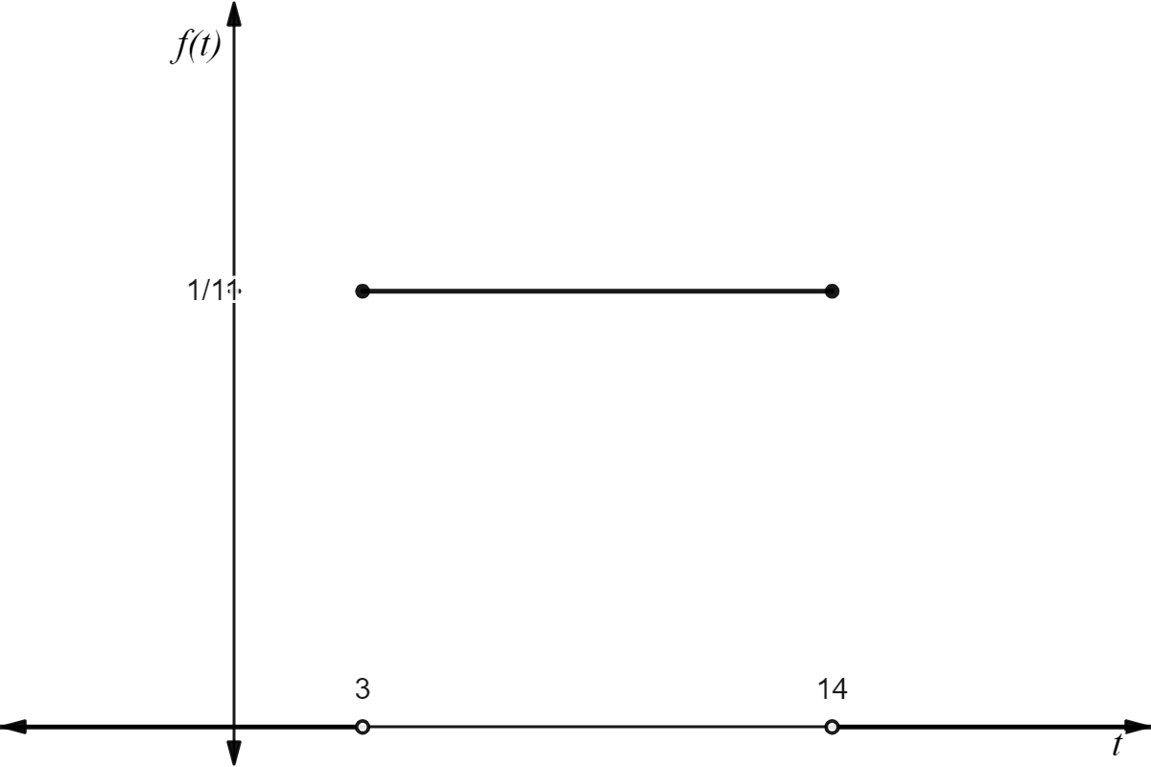
Specific behaviours
✓ Uniform distribution where $f\left(t\right)=1/11$
✓ Correct interval $3≤t≤14$
- Determine the probability that a randomly chosen interval between firings is:
  - at least seven minutes
Solution
$$P\left(X≥7\right)=\frac{1}{11}\left(14-7\right) \\ =\frac{7}{11}$$
Specific behaviours
✓ Correct answer
  - at least six minutes given that it is less than ten minutes.
Solution
$$P\left(X≥6|X<10\right)=\frac{P\left(6≤X<10\right)}{P\left(X<10\right)} \\ =\frac{\frac{1}{11}\left(10-6\right)}{\frac{1}{11}\left(10-3\right)} \\ =\frac{4}{7}$$
Specific behaviours
Correct use of conditional probability
✓ Correct answer
- Determine the value of $t$ for which $P\left(T<t\right)=P(T>4t)$
Solution
$$P\left(T<t\right)=P\left(T>4t\right) \\ \frac{1}{11}\left(t-3\right)=\frac{1}{11}\left(14-4t\right) \\ t-3=14-4t \\ 5t=17 \\ t=\frac{17}{5}$$
Specific behaviours
Correct expressions for $P(T<t)$ and $P(T>4t)$
✓ Correct answer

Question 3 [2, 4 - 6 marks]

Determine:

$$\left(a\right) \int{\frac{3x}{5x^{2}-2}.dx}$$

Solution
$$\int{\frac{3x}{5x^{2}-2}.dx}=\frac{3}{10}\int{\frac{10x}{5x^{2}-2}.dx} \\ =\frac{3}{10}\ln\left(5x^{2}-2\right)+c$$
Specific behaviours
✓ Integral includes $ln⁡(5x^{2}-2)$
✓ Correct answer with $+c$

(express answer as a single logarithm in exact form)
$$\left(b\right) \int_{-2}^{-1}{\frac{8x-6}{2x^{2}-3x}.dx}$$

Solution
$$\int_{-2}^{-1}{\frac{8x-6}{2x^{2}-3x}.dx}=2\int_{-2}^{-1}{\frac{4x-3}{2x^{2}-3x}.dx} \\ ={\left[2ln\left(2x^{2}-3x\right)\right]}_{\begin{aligned}-2 \\ \end{aligned}}^{-1} \\ =\left[2ln\left(2{\left(-1\right)}^{2}-3\left(-1\right)\right)\right]-\left[2ln\left(2{\left(-2\right)}^{2}-3\left(-2\right)\right)\right] \\ =2ln\left(5\right)-2ln{(14)} \\ =2ln\left(\frac{5}{14}\right)$$
Specific behaviours
✓ Integral includes $ln⁡(2x^{2}-3x)$
✓ Correct anti-derivative $2ln\left(2x^{2}-3x\right)$
✓ Correct substitution and simplification to $2ln{5}-2ln{14}$
✓ Correct answer
NOTE: Don’t penalise for ln(25/196)

Question 4 [2,2,3,2 - 9 marks]
The continuous random variable $X$ has probability density function:
$$f(x)=\left\{ \begin{aligned}\frac{x^{2}}{3}, &-1≤x≤2 \\ 0, &elsewhere\end{aligned}\right.$$
- Determine $E(X)$
Solution
$$E\left(X\right)=\int_{-∞}^{∞}{x.f\left(x\right).dx} \\ =\int_{-1}^{2}{x.\frac{x^{2}}{3}.dx} \\ = {\left[\frac{x^{4}}{12}\right]}_{\begin{aligned}-1 \\ \end{aligned}}^{2} \\ =\frac{5}{4}$$
Specific behaviours
✓ Correct integral
✓ Correct answer
- The variance of $X, Var\left(X\right)$ is $\frac{51}{80}.$ Determine:
  - $E\left(8X+2\right)$
Solution
$$E\left(8X+2\right)=8\left(\frac{5}{4}\right)+2=12$$
Specific behaviours
✓ Correct answer
NOTE: Follow-through for using value from (a)
  - $Var(8X+2)$
Solution
$$Var\left(8X+2\right)=8^{2}×\frac{51}{80}=\frac{204}{5}$$
Specific behaviours
✓ Correct answer

- Determine the cumulative distribution function $F\left(x\right).$
Solution
$$F\left(x\right)=\int_{-∞}^{x}{f\left(t\right).dt} \\ =\int_{-1}^{x}{\frac{t^{2}}{3}.dt} \\ = {\left[\frac{t^{3}}{9}\right]}_{\begin{aligned}-1 \\ \end{aligned}}^{x} \\ =\frac{x^{3}}{9}+\frac{1}{9}$$
Specific behaviours
✓ Correct integral $\int_{-1}^{x}{\frac{t^{2}}{3}.dt}$ (if uses $dx$ still give marks)
✓ Correct anti-derivative $\frac{x^{3}}{9}+\frac{1}{9}$
✓ Correct distribution – award 1/3 if uses 0 for lower bound, still states piecewise function
- Calculate $P(1<X<2)$
Solution
$$P\left(1<X<2\right)=P\left(X<2\right)-P\left(X<1\right) \\ =\left(\frac{2^{3}}{9}+\frac{1}{9}\right)-\left(\frac{1^{3}}{9}+\frac{1}{9}\right) \\ =1-\left(\frac{2}{9}\right) \\ =\frac{7}{9}$$
Specific behaviours
✓ Correct equation to determine $P(1<X<2)$ or uses f(x)
✓ Correct answer

End of section

Reading Time: An initial 2 minutes to view BOTH sections | MATHEMATICS METHODS : UNITS 3 & 4, 2022  Test 4 – (10%)  4.1.9 – 4.1.14, 4.2.1 – 4.2.7, 4.3.1 – 4.3.3
Time Allowed  24 minutes |  | First Name Surname | Marks  24 marks

Circle your Teacher’s Name: Mrs Alvaro Mrs Bestall Mrs Fraser-Jones Mr Gibbon/Luzuk Mrs Greenaway Mr Koulianos Mr Luzuk Mrs Murray Mr Tanday

Assessment Conditions: (N.B. Sufficient working out must be shown to gain full marks)

- Calculators: Allowed

- Formula Sheet: Provided

- Notes: Not Allowed

PART B – CALCULATOR ALLOWED
Question 1 [2,2,3 – 7 marks]
Tubs of Peter’s No Sugar Added ice-cream are labelled $750g.$ Peter’s know that customers will switch to a competitor’s brand if they suffer bad publicity. Tests on $500$ tubs of ice-cream show that they are normally distributed with a mean mass of $754g$ and a standard deviation of $4.2g.$
- Find the percentage of tubs that are over the labelled mass.
Solution
$$X\sim N(754, {4.2}^{2})$$
$P\left(X>750\right)=0.8295 ⇒ ≈83\%$will be over mass.
Specific behaviours
✓ Defining distribution
✓ Correct answer
- DIABETICFOODS order $10$ crates of ice-cream, each with $150$ tubs. How many tubs sent to DIABETICFOODS would be expected to be less than the labelled mass?
Solution
$$P\left(X<750\right)=1-0.8295=0.1705 \\ N=0.1705×10×150=255.75$$Approx 256 tubs.
Specific behaviours
✓ Evaluating $P(X<750)$
✓ Correct answer as a whole number (accept 255 or 256)
- Peter’s decide they need to improve the accuracy of their mass balances by recalibrating the machine. What will the mean mass (to the nearest gram) need to be so that less than $1\%$ of tubs are under the labelled mass?
Solution
z = -2.3263
$μ>759.77→μ=760$g
Specific behaviours
✓ States z-score
✓ Evaluating $μ$ for when $P\left(X<750\right)=0.01$
✓ States new $μ=760$g
Question 2 [2,2 – 4 marks]
For each of the following scenarios, comment on whether the sample selected is likely to be representative of the population. Justify your answer.

- A political scientist is interested in determining the likely outcome of an election. She contacts registered voters via phone by calling random home landline numbers in the electorate during weekday business hours (9am –5pm).
Solution
Not representative of the population as only people with landlines that are at home during business hours are being surveyed. These people are likely to be parents, unemployed, retired etc.
Specific behaviours
✓ Stating sample is not representative.
✓ One reason provided.

- A zoologist wishes to determine the average mass of bare-nosed wombats. He selects a sample of bare-nosed wombats in a nearby rescue shelter and determines the average mass.
Solution
Not representative of the population as wombats in rescue shelters are likely to be undermass due to health issues or overmass as they are well fed.
Specific behaviours
✓ Stating sample is not representative.
✓ One reason provided.

Question 3 [3,1,2 – 6 marks]
A personal trainer organizes a workout program that involves running 15 minutes on a straight track. The workout involves a run at a constant $6.5$ km/h for three minutes and then the speed, $s\left(t\right),$ is defined by the equation:
$$s\left(t\right)=6-\frac{\ln\left(t-2.99\right)}{t^{2}} km/h$$

- Sketch the graph of the speed during this run versus time on the axes below:
Solution
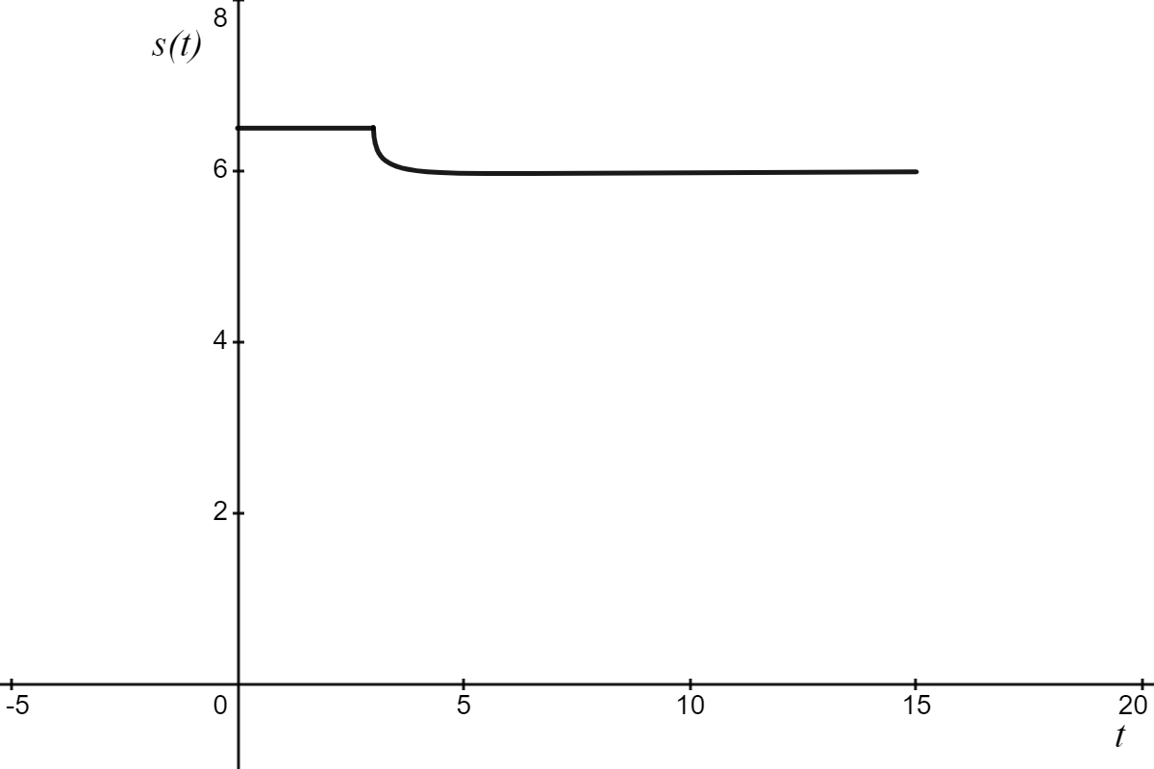
Specific behaviours
✓ Correctly graphed $0≤t≤3$
✓ Correctly graphed 3$≤t≤15$
✓ Scale on axes.

- At what time is the speed of the runner $6$ km/h?
Solution
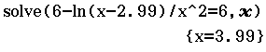
$$t=3.99 minutes \\ =3\min{59 s}$$
Specific behaviours
✓ Correct answer.

- At what time during the run is acceleration zero?
Solution
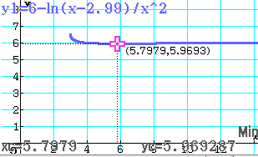

Acceleration is zero when $0≤t≤3 min$ and $t=5.80\min{ (5\min{48 s)}}$
Specific behaviours
✓ Correct answer $0≤t≤3 min$
✓ Correct answer

Question 4 [4,3 – 7 marks]
The continuous random variable $X$ has probability density function:

$$f(x)=\left\{\begin{aligned}ax+b, &1≤x≤3 \\ 0, &elsewhere\end{aligned}\right.$$

It is also known that $P\left(X<2\right)=5/8$
- Determine the value of the constants $a$ and $b$.
Solution
$$\frac{5}{8}=\int_{1}^{2}{ax+b.dx (1)} \\ \frac{5}{8}=\frac{3a}{2}+b$$ | $$1=\int_{1}^{3}{ax+b.dx (2)} \\ 1=4a+2b$$

Specific behaviours
✓ State equation 1 (can just use the integral form in Classpad)
✓ State equation 2.
✓ Correct value for $a$
✓ Correct value for $b$
- Hence, determine the expected value and variance of $X.$

Solution
$$E\left(X\right)=\int_{-∞}^{∞}{x.f\left(x\right).dx} \\ =\int_{1}^{3}{x.\left(-0.25x+1\right).dx} \\ =\frac{11}{6}$$

$$Var\left(X\right)=\int_{-∞}^{∞}{x^{2}.f\left(x\right).dx}-{\left(E\left(X\right)\right)}^{2} \\ =\int_{1}^{3}{x^{2}.\left(-0.25x+1\right).dx}-{\left(\frac{11}{6}\right)}^{2} \\ =\frac{11}{36}$$

Specific behaviours
✓ Evaluate $E(X)$
✓ Correct equation for $Var(X)$
✓ Evaluate $Var(X)$

End of section

